" League of legends" has been rated as one of the most popular games in history. The localization of the game interface cannot be ignored. Many Game Studios often ignore the importance of the game interface to the players. I want to analyze the interaction interface of League of legends.

Let's take a look at the previous version of the S5 qualifying process: contestants - class and hero selection - hero selection - start the competition. Looking at this process seems to be very simple and generous to quickly enter the game interface. Inevitably, we often encounter situations like this: in a player candidate like you want, if he is not satisfied with the position of his position, a variety of abuses begin, resulting in the whole process of the game is very unpleasant, affecting the player's experience in the game process. At the same time, we often have inconsistent behavior with our teammates in the game, which makes it difficult for us to understand in the game.

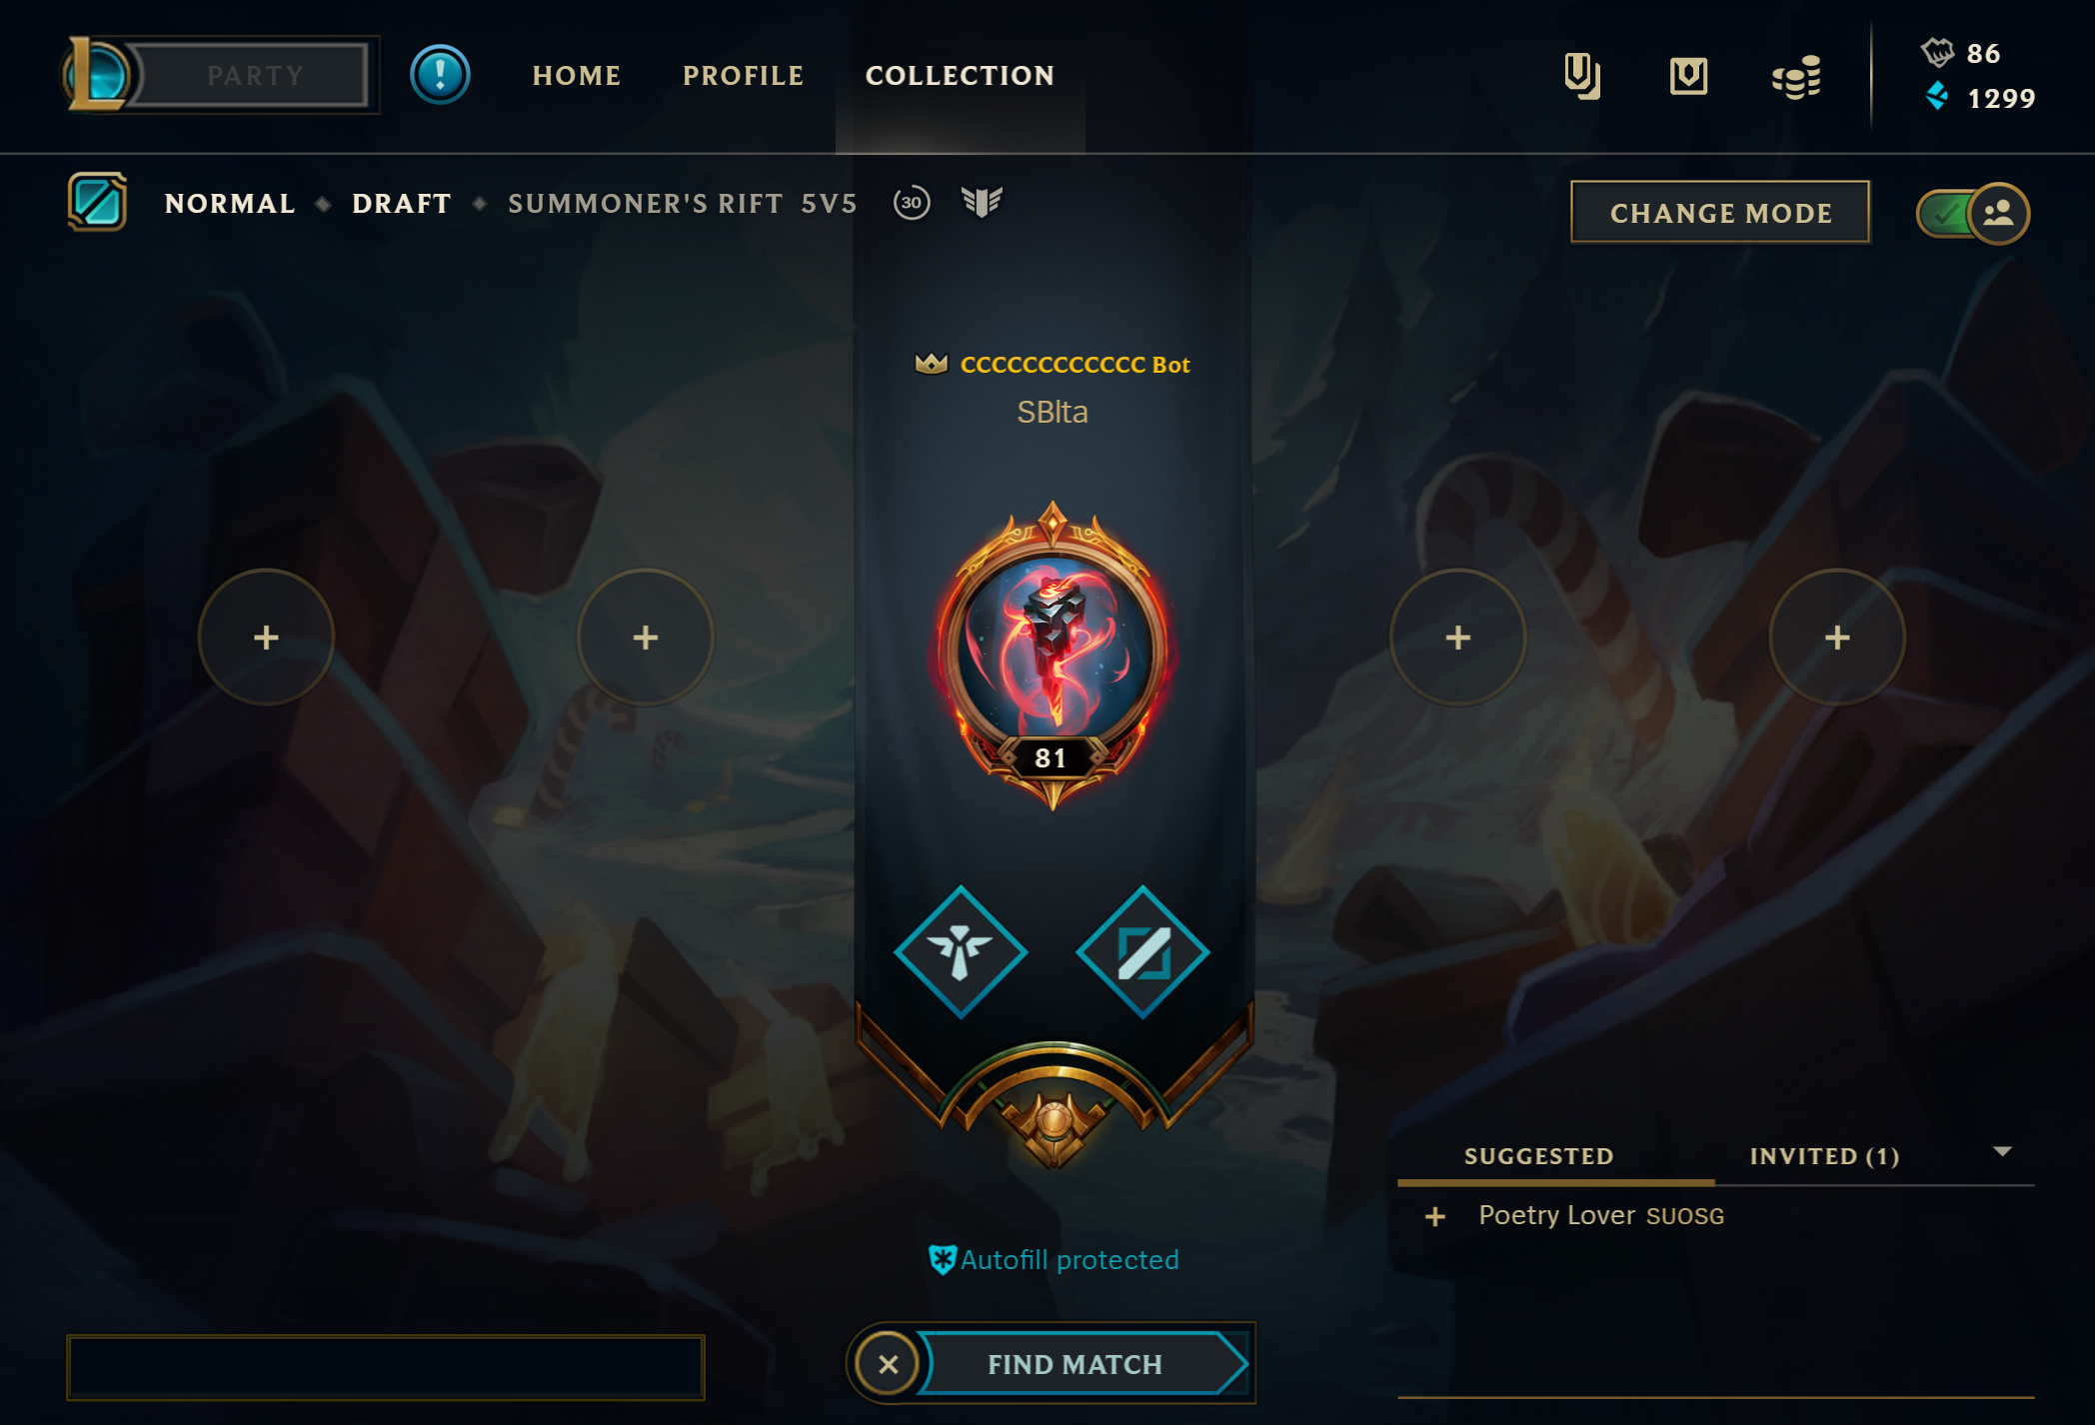

The new interface, BP (ban&pick), will be more strategic from now on. Players will no longer just ban some popular heroes, but actually think about how to defeat their opponents from BP.

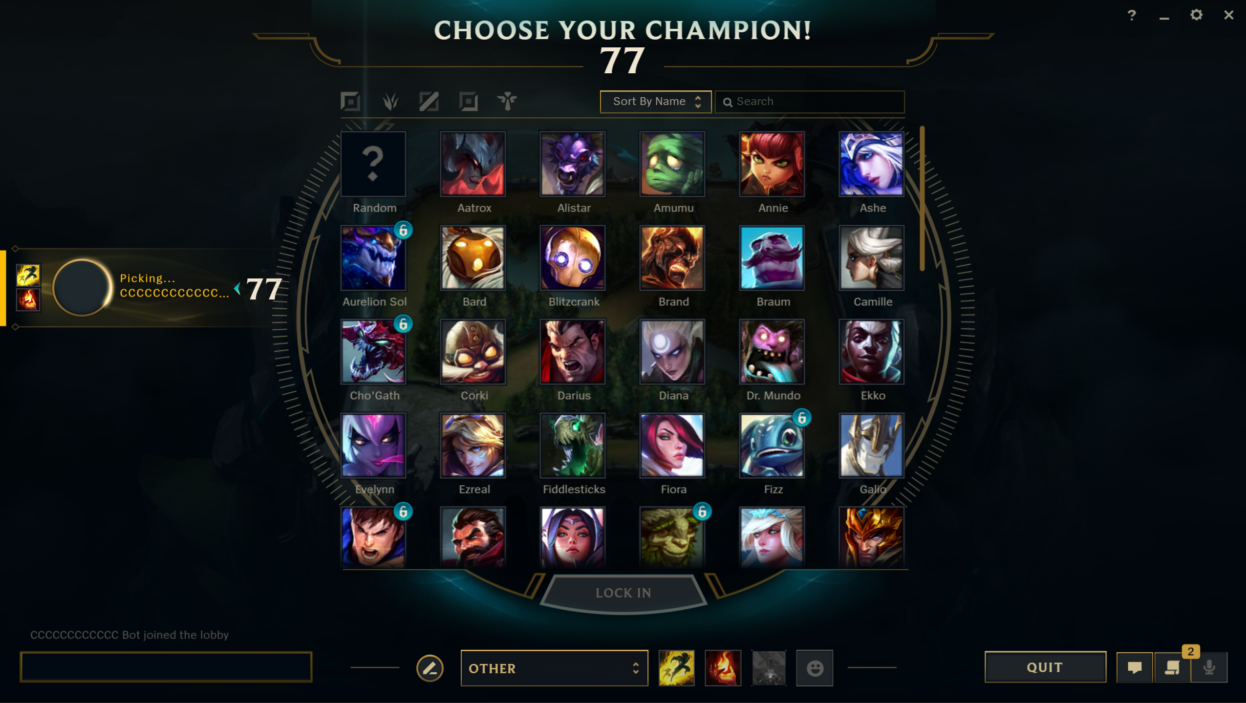

After entering the game, the first thing we see is a pile of status bars. This status bar is the most important for players. From the perspective of historical version, it has been placed at the middle and lower part of the screen. Previous versions have made different adjustments to all three statuses with skill upgrades, cooldowns, and mana shortages. The first is to upgrade the skills of the state, as shown in figure can see, in the new version is directly above the skill icon is an icon, said with the up arrow metaphor can be upgraded, compared with before + number, from the perspective of gestalt psychology, to better understand the relationship between the update icon and skill icon, and their correlation is higher, so that players will be able to understand the relationship between one, here more in line with the performance of the user's visual habit and habits.

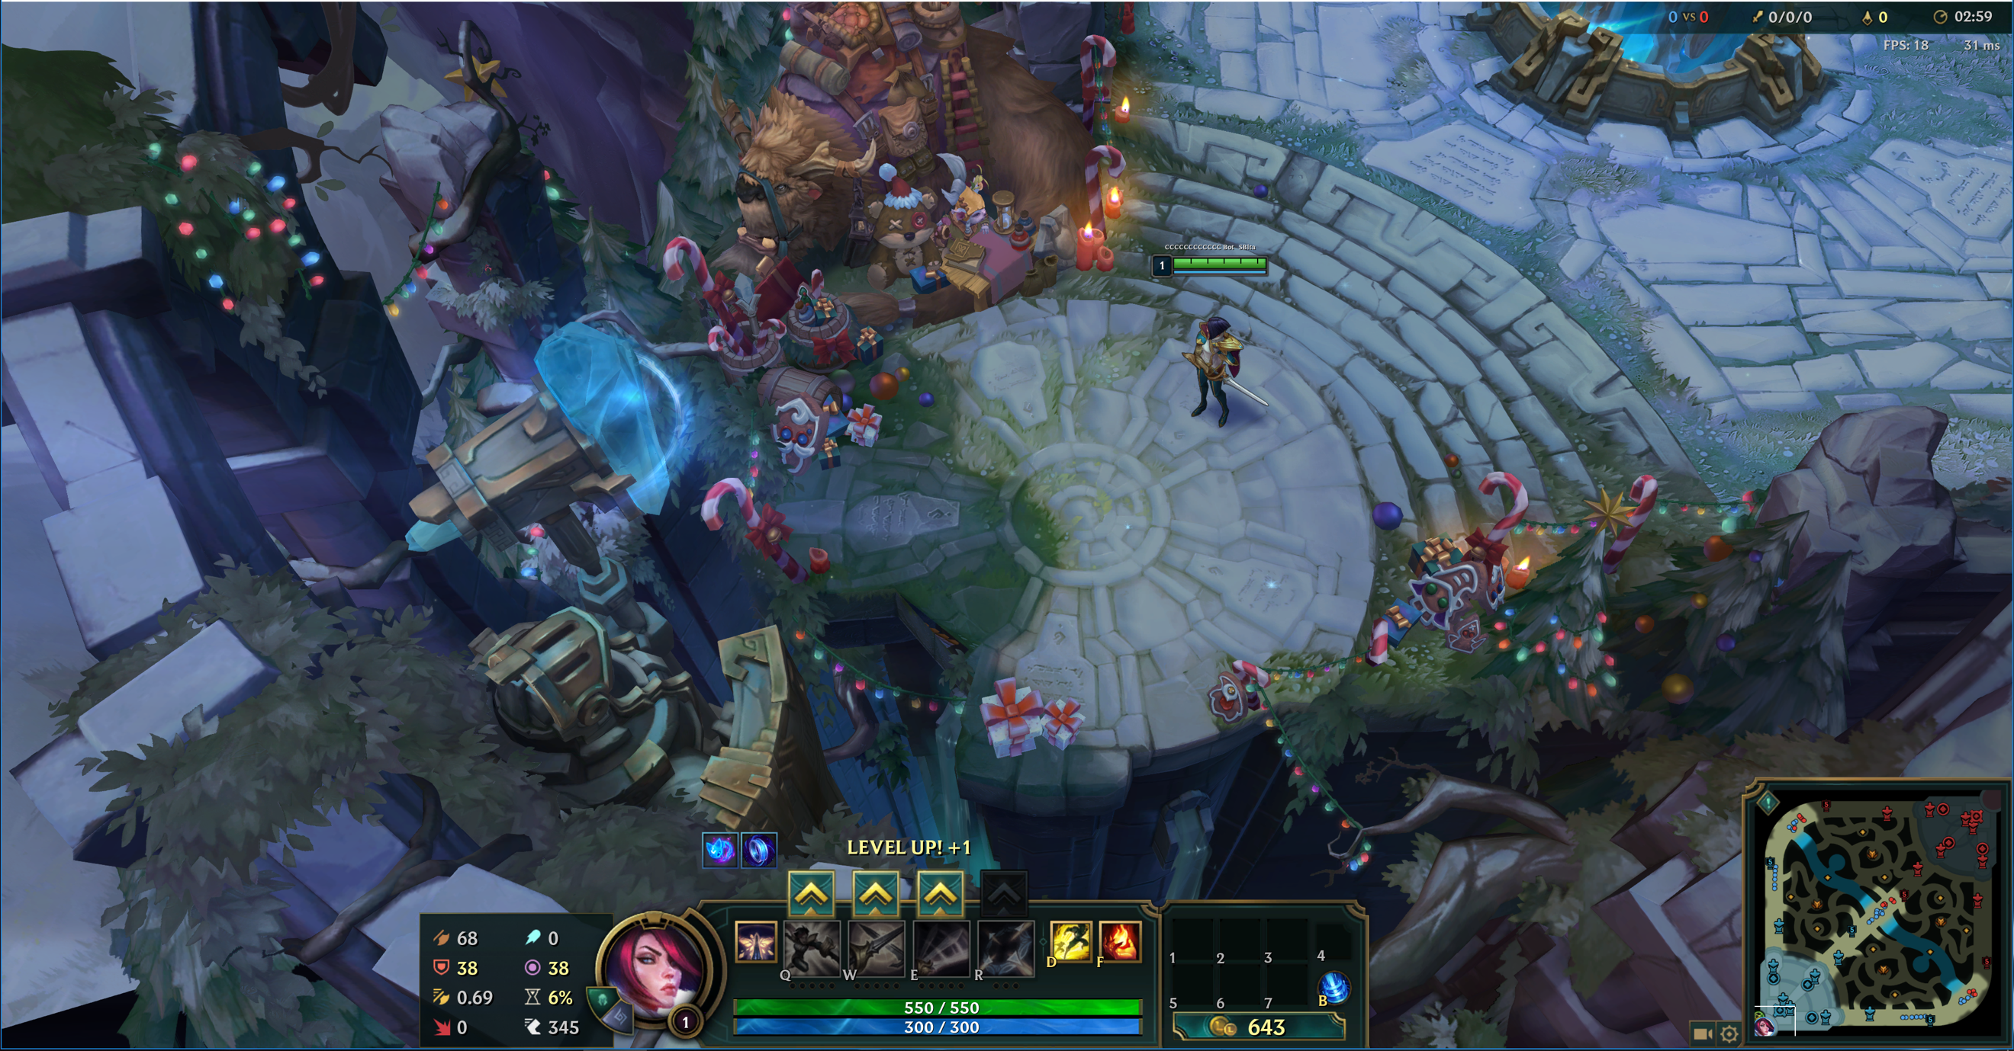

In my opinion, the new version of interactive interface has been humanized. Next, we discusse usability analysis. First of all, aesthetic and minimalist design. The new version of the interactive interface is very clear, for every detail of the map is depicted incisively and vividly. For the novice player, he can know where he is and where the players are from the lower right corner of the small map. The hits, deaths, and assists in the upper righthand corner also give the player a clear state of play without affecting the player's actions. Then, user control with freedom. For new players, the game only needs to be able to use the mouse to move and keyboard to release skills. So, for the user control and freedom aspect, this operation interface is very simple. Even though I think the interface is perfect, I can't deny that there are always problems with it. For example, Help and documentation questions. If a player has a problem with the interface in the game, it's hard for them to find a solution.

Let's say I'm hired to do user testing on this system. First of all, I will recruit old players who know about this game and new players who have never been exposed to this game for this study. Let the novice players play the game, see if they can play the game like the old players in a short time, and understand the various functions of the interactive interface. Finally, I will evaluate the success or failure of the system according to your feedback.